monday

Index opened down 80 bps and started strong -> no shorting.

HK this month in bear market, following last month’s rally (6-10%)

NASDAQ has been down since oct.

Short more nasdaq to hedge AAPL.

HK: hold short position due to favorable mDev and yDev.

US: increase short.

China: Short with flexible cover.

Markets:

China very strong, holding there with 100% >O ratio.

PD increased to 0.15% from 8 bps at open.

9:43 break out to 10960.

11:21

低开的影响比strong open的影响大.

Trading against mDev -> no addition.

Net position short for global mDev < 0 this month.

Weekend dev analysis:

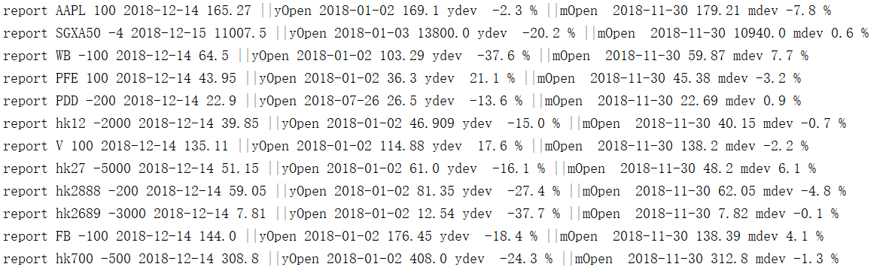

Half of this month is done.

AAPL is in the red down 8%. (long 100 shares). AAPL is down on the year.

SGX is flat.

WB up 8% against my short position.

PFE is down against my long position.

PDD flat.

HK 12 2689 2888 no remove.

FB up against my short position.

Almost markets are moving against all positions, not the time to add any position.